LABORATORY CHAPTER №4

Topic 1: FILE EXPLORER. OPERATIONS WITH FILES AND DIRECTORIES

File Explorer provides a graphical user interface for accessing the file systems. It is also the component of the operating system that presents many user interface items on the monitor such as the taskbar and desktop.

Explorer keyboard shortcuts:
- Win + E – Opens Windows Explorer
- Alt + Up – Switches to the parent folder in the hierarchy
- Alt P – Toggles the Preview pane
- Alt+Enter – Opens Properties for the selected object
- F2 – Allows you to rename selection
- Shift + Del – Deletes selection directly i.e. without moving it to Recycle Bin
- Alt (inside directory) – open menu toolbar.
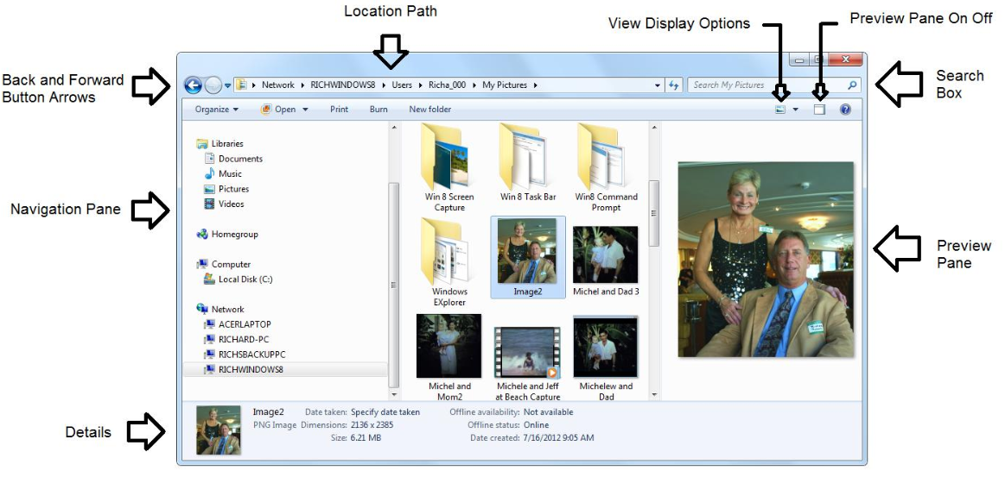

To use Windows Explorer:
- Move through your content by double-clicking folders, clicking on the Back and Forward buttons, or by clicking on headings in the Address bar.
- Preview files by selecting the Show the Preview pane button.
- When you double-click a file, it will open in the default program.

To change the view of the content in your folders:
You have several options for how you can view content in your folders. For example, you may prefer seeing Details when viewing file documents and Extra Large Icons when viewing pictures.

To change the view, select the View button and choose your preference.

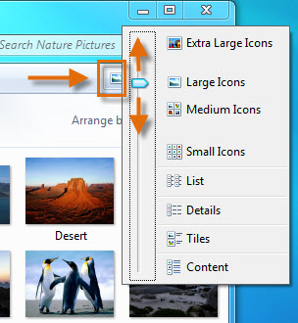

To change how your content is arranged:
Depending on the Library, you can Arrange content by month, day, rating, and other factors. Select the Arrange by button, and choose your preference.
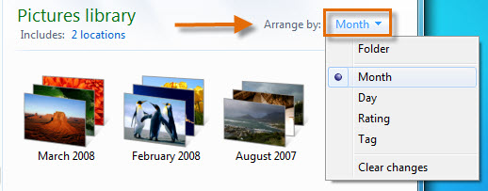

Using Search
To search your Libraries:
- Locate the Search bar at the top right corner of the Windows Explorer pane.
- Start typing a file name or keyword.
Search will start displaying matching items even before you finish typing.

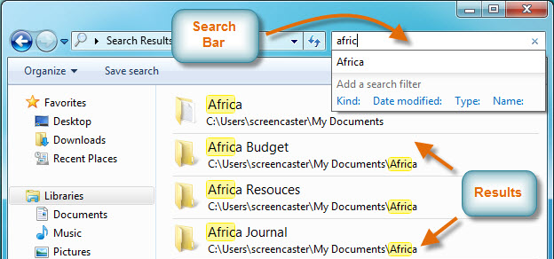

Search options and features
Search and Libraries have a few features that assist with identifying and arranging items. Tags can be added to certain items in order to improve search results. You can also rate and arrange content, like Pictures and Music, in the same manner. The Tag or Rating options are included in the Details pane, as shown below.

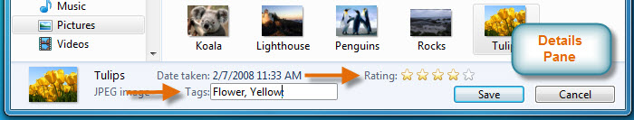

Various search filters can be applied to assist with finding content or narrowing a search. Depending on the Library, search filters might include Type, Date Modified, Tag, or Authors. Below is an example of the search filter in the Video Library.

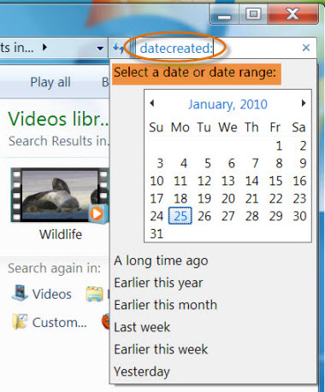
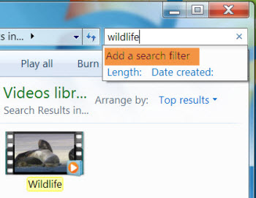

For even more search options, click the Organize button near the upper-left corner of the window and select Search and folder options.

To show hidden files.
Just click on the Organize button in any folder, and then select “Folder and Search Options” from the menu.
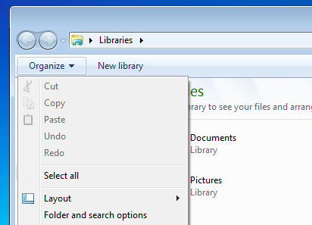

Click the View tab, and then you should select “Show hidden files and folders” in the list. If you are trying to get into the Windows directories, you might want to also remove the checkbox from “Hide protected operating system files” as well.
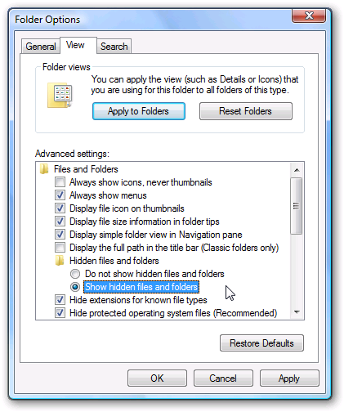

Once you are done, click OK.

Changing viewing preferences of one folder with or without subfolders
Windows/File Explorer usually tries to guess the best view for a folder - it displays photos and videos as thumbnails, documents with details, etc. In mixed folders, this might not work correctly. If you want to quickly change folder type, you can right-click the folder and choose Properties. Keyboard shortcut for this is Alt+Enter. Open Customize tab and choose a template from Use Optimize this folder. The names and number of available templates vary in different versions of Windows.
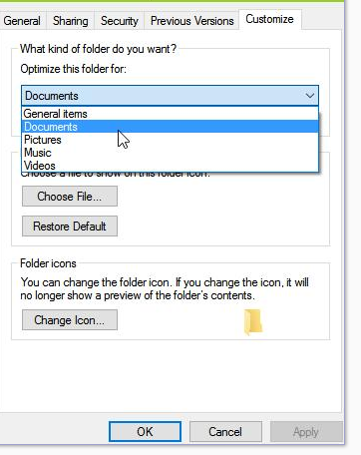
In case you want to apply the preferences to all subfolders of the current folder, check the Also apply this template to all subfolders check box.
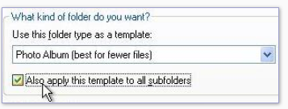
NOTE: You can also choose an existing photo or video for folder picture with the Choose File button. Please remember that the picture file has to in the same folder, not elsewhere!

Topic 2: WINDOWS HOT KEYS

You can make work in Windows more efficient and faster if you use not only the mouse, but also use hot keys — special key combinations designed to simplify and speed up work. For example, few people know that the very often used software - Explorer may be launched by simultaneously pressing Win + E.

Keyboard shortcuts in Windows (Applies to: Windows 10, Windows 8.1, Windows 7)
The following table contains general keyboard shortcuts.

Press this key To do this
F1 | Display Help
Ctrl + C (or Ctrl + Insert) | Copy the selected item
Ctrl + X | Cut the selected item
Ctrl + V (or Shift + Insert) | Paste the selected item
Ctrl + Z | Undo an action
Ctrl + Y | Redo an action
Delete (or Ctrl + D) | Delete the selected item and move it to the Recycle Bin
Shift + Delete | Delete the selected item without moving it to the Recycle Bin first
F2 | Rename the selected item
Ctrl + Right Arrow | Move the cursor to the beginning of the next word
Ctrl + Left Arrow | Move the cursor to the beginning of the previous word
Ctrl + Down Arrow | Move the cursor to the beginning of the next paragraph
Ctrl + Up Arrow | Move the cursor to the beginning of the previous paragraph
Ctrl + Shift with an arrow key | Select a block of text
Shift with any arrow key | Select more than one item in a window or on the desktop, or select text within a document
Ctrl with any arrow key + Spacebar | Select multiple individual items in a window or on the desktop
Ctrl + A | Select all items in a document or window
PrtSc | Makes a screenshot of a current workspace
F3 | Search for a file or folder
Alt + Enter | Display properties for the selected item
Alt + F4 | Close the active item, or exit the active program
Alt + Spacebar | Open the shortcut menu for the active window
Ctrl + F4 | Close the active document (in programs that allow you to have multiple documents open simultaneously)
Alt + Tab | Switch between open items
Ctrl + Alt + Tab | Use the arrow keys to switch between open items
Ctrl + Mouse scroll wheel | Change the size of icons on the desktop
Windows logo key + Tab | Cycle through programs on the taskbar by using Aero Flip 3-D
Ctrl+Windows logo key + Tab | Use the arrow keys to cycle through programs on the taskbar by using Aero Flip 3-D
Alt + Esc | Cycle through items in the order in which they were opened
F6 | Cycle through screen elements in a window or on the desktop
F4 | Display the address bar list in Windows Explorer
Shift + F10 | Display the shortcut menu for the selected item
Ctrl + Esc | Open the Start menu
Alt + underlined letter | Display the corresponding menu
Alt + underlined letter | Perform the menu command (or other underlined command)
F10 | Activate the menu bar in the active program
Right Arrow | Open the next menu to the right, or open a submenu
Left Arrow | Open the next menu to the left, or close a submenu
F5 (or Ctrl + R) | Refresh the active window
Alt + Up Arrow | View the folder one level up in Windows Explorer
Esc | Cancel the current task
Ctrl + Shift + Esc | Open Task Manager
Shift when you insert a CD | Prevent the CD from automatically playing
Left Alt + Shift | Switch the input language when multiple input languages are enabled
Ctrl+Shift | Switch the keyboard layout when multiple keyboard layouts are enabled
Right or Left Ctrl + Shift | Change the reading direction of text in right-to-left reading languages

Dialog box keyboard shortcuts
The following table contains keyboard shortcuts for use in dialog boxes.

Press this key To do this
Ctrl + Tab | Move forward through tabs
Ctrl + Shift + Tab | Move back through tabs
Tab | Move forward through options
Shift + Tab | Move back through options
Spacebar | Select or clear the check box if the active option is a check box
Arrow keys | Select a button if the active option is a group of option buttons
F1 | Display Help
F4 | Display the items in the active list
Backspace | Open a folder one level up if a folder is selected in the Save As or Open dialog box

Windows logo key keyboard shortcuts
The following table contains keyboard shortcuts that use the Windows logo key

Press this key To do this
Windows logo key | Open or close the Start menu.
Windows logo key + Pause | Display the System Properties dialog box.
Windows logo key + D | Display the desktop.
Windows logo key + M | Minimize all windows.
Windows logo key + Shift + M | Restore minimized windows to the desktop.
Windows logo key + E | Open Computer.
Windows logo key + F | Search for computers (if you're on a network).
Windows logo key + L | Lock your computer or switch users.
Windows logo key + R | Open the Run dialog box.
Windows logo key + T | Cycle through programs on the taskbar.
Ctrl+Windows logo key + Tab | Use the arrow keys to cycle through programs on the taskbar by using Aero Flip 3-D.
Ctrl+Windows logo key + B | Switch to the program that displayed a message in the notification area.
Windows logo key + Spacebar | Preview the desktop.
Windows logo key + Up Arrow | Maximize the window.
Windows logo key + Left Arrow | Maximize the window to the left side of the screen.
Windows logo key + Right Arrow | Maximize the window to the right side of the screen.
Windows logo key + Down Arrow | Minimize the window.
Windows logo key + Home | Minimize all but the active window.
Windows logo key + Shift + Up Arrow | Stretch the window to the top and bottom of the screen.
Windows logo key + Shift + Left Arrow or Right Arrow | Move a window from one monitor to another.
Windows logo key + P | Choose a presentation display mode.
Windows logo key + G | Cycle through gadgets.
Windows logo key + U | Open Ease of Access Center.
Windows logo key + X | Open Windows Mobility Center.

Windows Explorer keyboard shortcuts

Press this key To do this
Ctrl + N | Open a new window
Ctrl + W | Close the current window
Ctrl + Shift + N | Create a new folder
End | Display the bottom of the active window
Home | Display the top of the active window
F11 | Maximize or minimize the active window
Ctrl + Period (.) | Rotate a picture clockwise
Ctrl + Comma (,) | Rotate a picture counter-clockwise
Num Lock + Asterisk (*) on numeric keypad | Display all subfolders under the selected folder
Num Lock + Plus Sign (+) on numeric keypad | Display the contents of the selected folder
Num Lock + Minus Sign (-) on numeric keypad | Collapse the selected folder
Left Arrow | Collapse the current selection (if it's expanded), or select the parent folder
Alt + Enter | Open the Properties dialog box for the selected item
Alt + P | Display the preview pane
Alt + Left Arrow | View the previous folder
Backspace | View the previous folder
Right Arrow | Display the current selection (if it's collapsed), or select the first subfolder
Alt + Right Arrow | View the next folder
Alt + Up Arrow | View the parent folder
Ctrl + Shift + E | Display all folders above the selected folder
Ctrl + Mouse scroll wheel | Change the size and appearance of file and folder icons
Alt + D | Select the address bar
Ctrl + End | To instantly go to the bottom of a webpage or other program that scrolls
Ctrl + F | Select the search box

ADDITIONAL TASK FOR MASTERING SKILLS

Operation with files and directories
A file is a collection of data that is stored on disk and that can be manipulated as a single unit by its name.
A directory is a file that acts as a folder for other files. A directory can also contain other directories (subdirectories); a directory that contains another directory is called the parent directory of the directory it contains.
A directory tree includes a directory and all of its files, including the contents of all subdirectories. (Each directory is a "branch" in the "tree.") A slash character alone (`/') is the name of the root directory at the base of the directory tree hierarchy; it is the trunk from which all other files or directories branch.
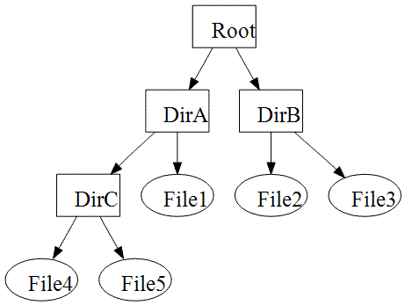

A path, the general form of the name of a file or directory, specifies a unique location in a file system ([Drive letter:]\[Directory}\[Subdirectory1]\[File name] ->c:\user\docs\letter.txt).

Window command line (DOS command line/prompt) for operation with files and directories

The command line is one of the features of Windows that provides input to MS-DOS commands and other computer commands. The importance of this command line is that it allows you to perform tasks without the help of the Windows graphical interface.
Open command line to do that follow this steps:
- Open prompt command line:
- Press + R on your keyboard
OR
- Click Start and type cmd (cmd.exe) in command line OR
- Open Task Manager with more details. Choose File and then Run New Task. Type cmd or cmd.exe, and hit OK to open up a regular command prompt
OR
Open the Start menu, and click/tap on All apps at the bottom. In All apps, scroll down and expand the Windows System folder, then click/tap on Command Prompt. (for Windows 10).
Typically Windows starts you at your user directory. This prompt tells us we are in the C: drive (the default drive letter of the hard drive) and currently , in this examole, in the Mrhope directory, which is a subdirectory of the Users directory.
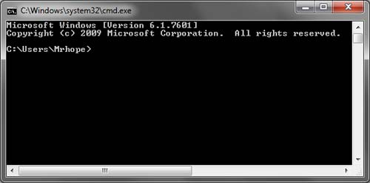
Prompt commands for files and directories:
NOTE: Command Prompt is not case sensitive, meaning that commands can be typed with capital letters, lowercase or any combination of them.
NOTE: Almost all commands can be accompanied with an indication of their execution attributes. To determine the attributes, as well as getting help information you should type /? after the command name. (Syntax: DIR /?).

- Change the current drive
Syntax: Drive letter

- CD (Change Directory). This command enables you to change the current folder or, in
other words, to navigate to another folder from your computer. You can move back to the root directory by typing cd\.
Syntax: CD [Drive>:][<Path>]

- DIR. Displays a list of a directory's files and subdirectories.
Syntax: dir [<Drive>:][<Path>][<FileName>]
NOTE: By indicating <FileName> you can find info about all or specific files in current directory. (all txt files -> *.txt).

- MD (same as mkdir). Creates a directory or subdirectory.
Syntax: md [<Drive>:]<Path>\<Path>…

- REN (same as rename) Renames files or directories.
Syntax: ren [<Drive>:][<Path>] <FileName1> <FileName2>
NOTE: You can rename all specific file type in the directory in one step (ren *.txt *.doc)

- RD (same as rmdir) Deletes a directory.
Syntax: rd [<Drive>:]<Path>\<Path>…

- COPY. Copies one or more files from one location to another.
Syntax: copy <Source> [+<Source>[+ ...]] [<Destination>] (copy abсd.txt d:\user)

- DEL (same as erase). Deletes one or more files. If you use /p (del /p 1.txt), del displays
the name of a file and sends the following message: FileName, Delete (Y/N)?
Syntax: del <Names>
NOTE: If you use del to delete a file from your disk, you cannot retrieve it.

- TYPE. Displays the contents of a text file. Use the type command to view a text file
without modifying it.
Syntax: type [<Drive>:][<Path>]<FileName>

- MOVE. Moves one or more files from one directory to another directory.
Syntax: move [<Source>] [<Target>]

- TREE. Allows to view a listing of files and folders in an easy to read listing.
Syntax: tree [<Drive>:][<Path>]

NOTE: Print or Save a Directory Listing to a File (*txt, *docx…). Printing a directory listing is something you may not do often, but when you need to print a listing of a directory with a lot of files in it, you would rather not manually type the filenames. To print a lsting of a current directory:
Syntax: dir > Fiename.txt

NOTE: To copy text from a command prompt window
1. | Right-click the title bar of the command prompt window, point to Edit, and then click Mark.
2. | Click the beginning of the text you want to copy.
3. | Press and hold down the SHIFT key, and then click the end of the text you want to copy (or you can click and drag the cursor to select the text).
4. | Right-click the title bar, point to Edit, and then click Copy.

